1)Write a program to display HelloWorld.

The Default Main Activity Java Code
package com.example.helloworldapplication;
import androidx.appcompat.app.AppCompatActivity;
import android.os.Bundle;
public class MainActivity extends AppCompatActivity {
@Override
protected void onCreate(Bundle savedInstanceState) {
super.onCreate(savedInstanceState);
setContentView(R.layout.activity_main);
}
}

activity_main.xml
<?xml version="1.0" encoding="utf-8"?>
<androidx.constraintlayout.widget.ConstraintLayout xmlns:android="https://schemas.android.com/apk/res/android"
xmlns:app="http://schemas.android.com/apk/res-auto"
android:layout_width="match_parent"
android:layout_height="match_parent"
tools:context=".MainActivity">
<TextView
android:layout_width="wrap_content"
android:layout_height="wrap_content"
android:text="Hello World!"
app:layout_constraintBottom_toBottomOf="parent"
app:layout_constraintLeft_toLeftOf="parent"
app:layout_constraintRight_toRightOf="parent"
app:layout_constraintTop_toTopOf="parent" />
</androidx.constraintlayout.widget.ConstraintLayout>
<TextView
android:layout_width="wrap_content"

android:layout_height="wrap_content"

android:text="Hello World!"

android:textSize="50dp"

android:textColor="#800000"

app:layout_constraintBottom_toBottomOf="parent"

app:layout_constraintLeft_toLeftOf="parent"

app:layout_constraintRight_toRightOf="parent"

app:layout_constraintTop_toTopOf="parent" />

STRINGS.xml
<resources>

<string name="app_name">Hello World Application</string>

</resources>

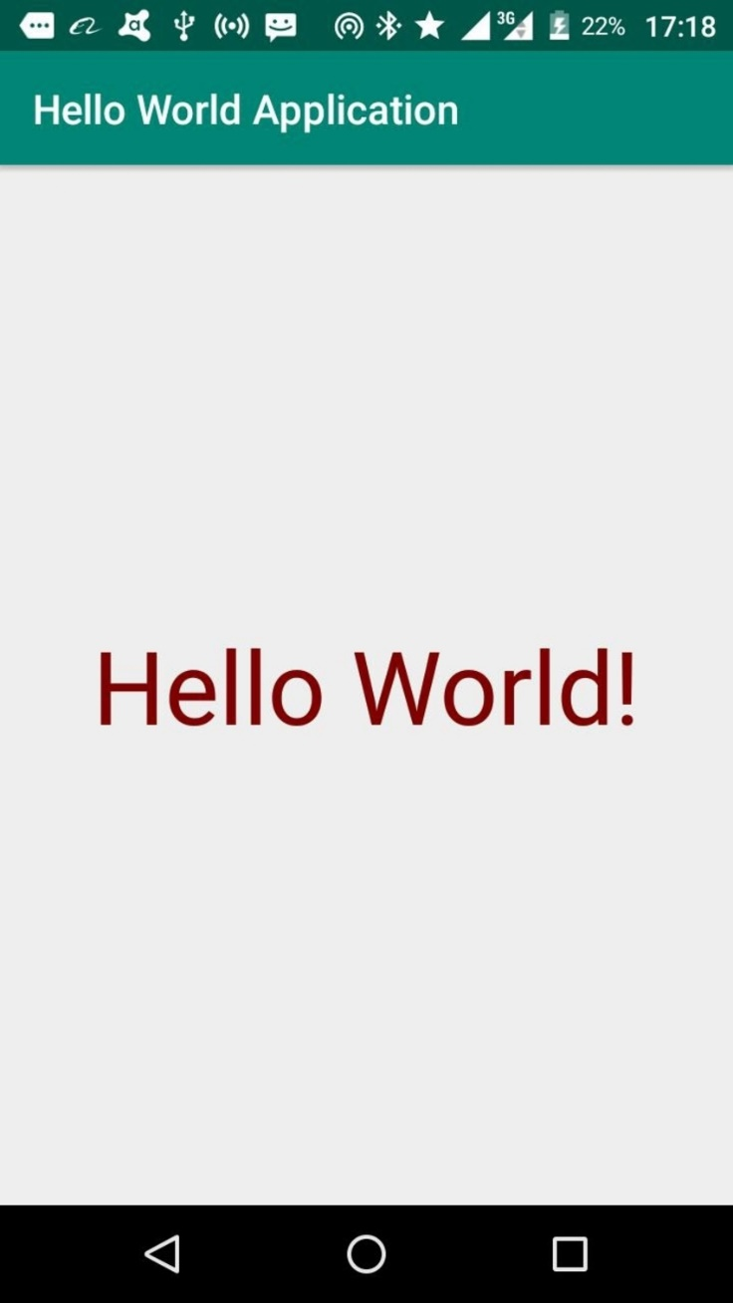

2)Write a program to display student name and marks.
AndroidManifest.xml :
<?xml version="1.0" encoding="utf-8"?>
<manifest xmlns:android="http://schemas.android.com/apk/res/android"
package="com.blogspot.codingatharva.firstapp" >
<application
android:allowBackup="true"
android:icon="@mipmap/ic_launcher"
android:label="@string/app_name"
android:roundIcon="@mipmap/ic_launcher_round"
android:supportsRtl="true"
android:theme="@style/AppTheme" >
<activity android:name=".MainActivity" >
<intent-filter>
<action android:name="android.intent.action.MAIN" />
<category android:name="android.intent.category.LAUNCHER" />
</intent-filter>
</activity>
</application>
</manifest>
activity_main.xml:
<?xml verson="1.0" encoding="utf-8"?>
<RelativeLayout xmlns:android="http://schemas.android.com/apk/res/android"
xmlns:tools="http://schemas.android.com/tools"
android:layout_width="match_parent"
android:layout_height="match_parent
android:paddingLeft="16dp"
android:paddingRight="16dp"
android:paddingTop="16dp"
tools:context=".MainActivity">
<TextView
android:id="@+id/student_name"
android:layout_width="wrap_content
android:layout_height="wrap_content"
android:layout_centerInParent="true"
android:text="Atharva Agrawal" />
<TextView
android:id="@+id/student_marks"
android:layout_width="wrap_content"
android:layout_height="wrap_content"
android:layout_toRightOf="@+id/student_name"
android:layout_centerInParent="true"
android:paddingLeft="16dp"
android:text="99" />
</RelativeLayout>

MainActivity.java:
package com.blogspot.codingatharva.firstapp;
import androidx.appcompat.app.AppCompatActivity;
import android.os.Bundle;
public class MainActivity extends AppCompatActivity {
@Override
protected void onCreate(Bundle savedInstanceState) {
super.onCreate(savedInstanceState);
setContentView(R.layout.activity_main);
}
}
Output:
